Tutorial 1 solution

Exercise 1.

Consider an email client software. The client has one mailbox which consists of several folders. Each folder contains some messages. A message cannot exist in more than one folder. A user can invoke a view on a message and in fact a user may have various views, each corresponding to one message

1. Illustrate the appropriate mechanisms in order to identify concepts and their associations.
2. Noun-phrase identification: Mailbox, Folder, Message, View. C*lient and user refer to the same.*
3. Conceptual class category list: Containers of other things (Mailbox, Folder) (Folder, message)
4. Common associations list:
   1. *A* logical part of *B*: (Mailbox, Folder), (Message, Folder)
   2. *A* is a description of *B:* (View, Message)
   3. *A* is captured in *b:* (View Message)
5. Create a domain model for the email client.

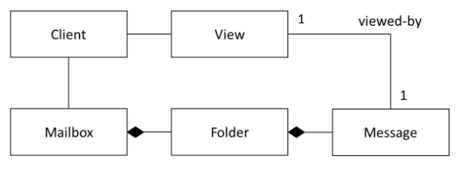

1. Define the term *multiplicity expression* and show its applicability on the domain model.

Multiplicity: How many instances of one type may be associated with an instance of another type at one point in time

Mailbox – Folder: one to many, Folder-Message: one to many

1. Define the term *aggregation* (and its different types) and clearly illustrate its applicability to the domain model.
   1. Mailbox is comprised of folders, and Folders are comprised of Messages. Note that the relationship is composition, which is a special type of aggregation, where the life of the composed items depends on the life of the containers

Exercise 2.

* Our system is the Registrar office of a University where students go in order to enroll for classes. Consider the following success scenario of use case Process Registration:
* A student arrives at the Registrar’s office in order to enroll in one or more classes. The clerk will access the terminal in order to initiate a new enrollment session (you may assume that they already have been authenticated by the system). Each enrollment session captures the date and time it was initiated. The clerk will proceed to enroll the student in each class requested. For each class, the clerk will enter the student name and identification number and the class identification number. In response to each entry, the system will display a description and a confirmation. At the end of the session, the system will display a confirmation of the procedure and the total amount of tuition fees due. The clerk will then initiate a payment of tuition fees and the system will respond with the change due and a receipt

Create a domain model based on the above scenario.

